**Detailed design**

**Introduction**

The detailed design document is designed to explain the complete design structure of the system Online Book Store. In this document the overall working of each module are shown. The working of the module is represented in the form of flowchart and the description about each of the module is explained in this section. Overall the complete structure of each of the modules of the system is designed by referring the software requirement specification and database design documents.

**Applicable documents**

Detailed design is performed using the following documents:

* System Requirements Specification
* System Design
* Database Design

**Structure of the software package**

Includes the following components:

* **Admin account module**: Admin is the one who manages the entire website and also has the full authority over all the activities of the online book store. The admin monitors the other users of the website.
* **Book seller account module:** Book seller is added by the admin. They must add the different categories of books published in their publications for the user to purchase.
* **Customer account module:** Customer must register by entering all the details. Once the registration is successful they can login to the web page by entering valid login credentials.
* **Category module**: in this module, admin can add the various categories. The category includes the name of the category and description about the category.
* **Author module**: In this module, the admin can add the various authors all around the world. The customers can view the books written by various authors through this module.
* **Book module**: this module allows the admin or the book seller to add the books of different categories by mentioning the publication, description and type of the book. It also includes e-book, paperback book and hardcover book.
* **Digital download module:** If the customer has ordered e-book and completed the payment process then they can download the softcopy of the book in this module.
* **Purchase module:** The purchase made by the customer can be viewed in this module. The admin can update the delivery status of the customer’s purchase in this module.
* **Billing module:** This module allows the customer to view their bill receipt once the payment is done. The book sellers and the admin can view the billing report in this module.

**Use case diagram**

Use case diagram is a representation of the working of the system. It is used to show the relationship between the system and the different users of the software. This shows how the system works including all of its components. The circle or ellipse symbol can be used to represent this diagram.

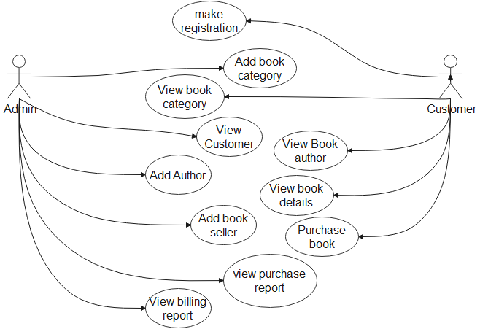

**Sequence diagram**

Sequence diagram is the pictorial representation of the interactions of the system. In this diagram using the actors and the arrows how the system interacts with each of its actors is pictured. In an order in which the system behaves with its actors and other elements is drawn in the sequence diagram.

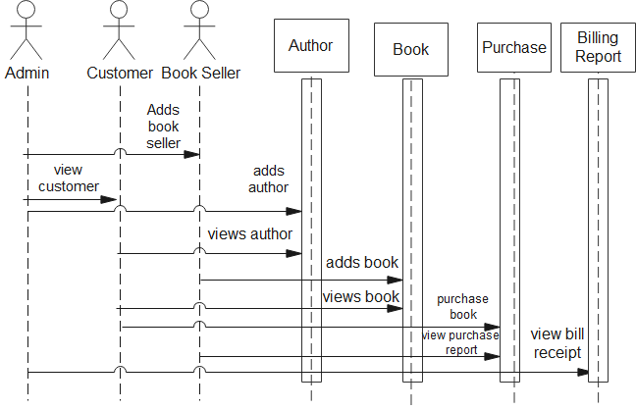

**Collaboration diagram**

Collaboration diagram describes the communication between the objects of the system. This involves the communication of each object of the system with other objects of the system. In this diagram clear working of the objects is depicted which makes the users understand the software better.

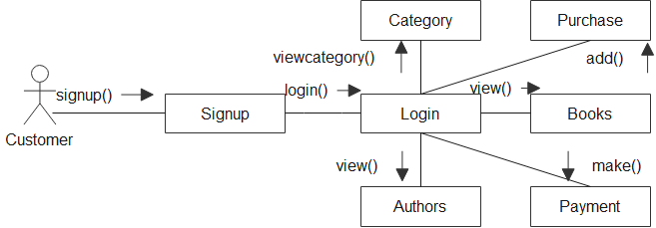

**Activity diagram**

Activity diagram illustrates the entire activity of the system. All the actions that must happen in the system from the start till the end is shown in the activity diagram. Activity diagram shows all the decisions that is made in every step of the system.

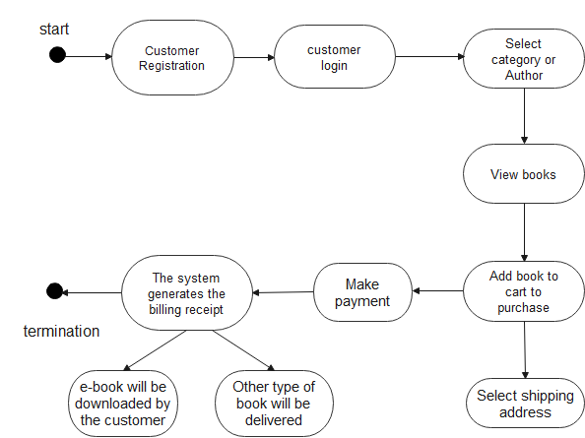

**Class diagram**

Class diagram shows the relationship between the class, it’s objects and attributes of the system. The relationship between each class with another class along with its attributes is depicted here. It illustrates the connection of each class of the system with one another.

